REPORT ON ATLANTIS WOMEN’S DAY FUNCTION ON 7 AUGUST 2014, PRESENTED BY THE AFRIKAANSE TAALRAAD (ATR) IN COLLABORATION WITH WESFLEUR LIBRARY/CITY OF CAPE TOWN AND WORLD VISION

1. Introduction and background

The Afrikaanse Taalraad's Women's Day celebrations that took place in Atlantis on 7 August 2014, was the first opportunity for the organisation to give practical content to its mission to inspire women to become partners in empowerment through language, given a mother's central role in choosing her child(ren)'s language. The event was attended by a heterogeneous group of women, almost 140 in total, among whom a number of retired women teachers from Atlantis and the adjacent areas who were especially given the envisaged reading intervention programme for learners at Atlantis schools, as an outcome of the Women's Day event.
The need for women's empowerment, on the one hand, and youth empowerment, on the other, provided the ideal context for the ATR to realise its mission in this predominantly Afrikaans-speaking community. The specific aims of the Atlantis Women's Day event were to inspire the local women to self-realisation, to create awareness of the value of the mother tongue as language of instruction, and to mobilise them to become involved in developing a reading culture and improving learners' reading skills. The comment of Ms Cheryl Allen, WCED education specialist in the Atlantis area, says it all: "The manner in which it (die Vrouedagprogram) was directed at empowerment of women for the sake of our children was absolutely powerful."
2. The Women's Day programme
The versatile programme was competently directed by the well-known radio and TV personality, Elana Afrika, who was herself visibly moved by the events of the day. The programme included: a fitting opening prayer and spiritual dance by Pastor Leni Maya and Ms Ann Frans, respectively, setting the tone for the rest of the programme; fitting items of song rendered by the staff of Wesfleur library; an input by Dr Michael le Cordeur, chairperson of the ATR, on the rationale for the ATR celebrating Women's Day, and a powerful motivational address by the main speaker, Prof. Maureen Robinson, Dean of the Faculty of Education at the US. She remarked on the significance of the library as an empowering space for the Women's Day event and challenged the women to live positively, to unleash the rock power in themselves. Her challenge to the women to establish reading clubs, which she dubbed the "Trotse Rotse" (Proud Rocks), created a lot of excitement. It was decided there and then that the staff of Wesfleur library would be launching these reading clubs with the competent guidance and support of Ms Frances Hearne, chief librarian, and in partnership with the ATR and the University of Stellenbosch.
The responses to the keynote speech - by Ms Cheryl Allen, curriculum manager at the district office of the Western Cape Education Department, and Mr Wayne du Plessis, chief executive officer of World Vision Atlantis - also inspired the women to take charge of their lives, motivated them to take the initiative in the fight against underdevelopment and poverty, and gave an undertaking of continued support. The ensuing discussion not only confirmed the existence of a reading problem among the learners, but also the need for collective intervention.

Ms Hearne invited the women to work together with Wesfleur Library in creating a culture of reading in Atlantis by regularly taking out books and bringing their children to the libary for reading support. The challenges with regard to sustainability, highlighted by Ms Hearne and one of her staff members, as well as the invitation to make use of the venues of the City of Cape Town for the envisaged reading intervention programme were duly noted.

The programme also included items by local music and drama artists, Tanya Branders, Tonay O'Connell and Josh Jansen and the highlight: the learners of Parkview Primary School who had the audience in awe with their excellent rendition of a drama based on the historic events when thousands of women took to the streets to protest against the pass laws. The drama was written by their teacher, Natasha Plaatjies. Elana Afrika, who was visibly moved, congratulated the community with the talent displayed by their children.

A value-adding component, made possible by World Vision, was the provision of free routine medical tests for the women.

Thanks to World Vision Atlantis each guest received one or two children's books to read to pre-school children to stimulate in them a love for reading and for books. Wesfleur Library and the ATR - thanks to Biblionef - also presented the women with valuable books. With the help of AfriForum each of the women received a small gift. The excitement during the lucky draws also contributed to the joyous event. The main contributors to the programme of the day were presented with surprise gifts, among others a personalised Atlantis Women's Day mug.

Afterwards there was an opportunity for the women to mingle, to take photographs and to enjoy some refreshments, while some made use of the offer of free medical tests.

3. Media coverage

The Atlantis Women's Day event and the ATR's message of empowerment through language in partnership with women was given valuable media coverage on a national TV news channel, in a local newspaper and on RSG.

4. Outcome of the Atlantis Women's Day event
The dream is to launch a large-scale, multi-facetted reading support project for Atlantis involving various organisations that are already engaged in promoting reading. These organisations include member organisations of the Taalraad, and other role players such as World Vision, Wesfleur Library (City of Cape Town) and the Western Cape Education Department.

A first planning meeting for all stake holders, coordinated by the Taalraad, was scheduled to take place in Atlantis on Friday 22 August 2014.

5. In conclusion

The successful Women's Day function in Atlantis and the envisaged reading intervention programme would of course not have been possible without the committed cooperation of various institutions and inviduals. Mr Waldy Kastoor, member of the ATR Board of Directors and principal of Parkview Primary School, thanked all those involved in the event: guest speaker Prof. Maureen Robinson, Elana Afrika, the other participants in the day's event, the Afrikaanse Taalraad, Wesfleur Library/City of Cape Town, World Vision, AfriForum, service providers and the guests - for attending the event.

Thanks is also due to chairperson Dr Le Cordeur, vice-chairperson Alana Bailey and ATR Board member Mr Waldy Kastoor, who as photographer plays a valuable role in documenting ATR projects, chief librarian Ms Frances Hearne for taking care of the logistics in Atlantis, as well as colleagues Prof. Jacques van der Elst and Jannie Earle for ongoing support from the office of the Taalraad.

Ria Olivier
Project Manager
14 August 2014

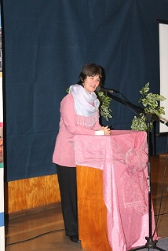  Dean as guest speaker at Women’s Day in Atlantis | Elana Afrika was the programme director  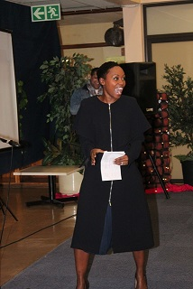 | 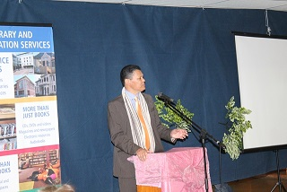  ATR chairperson welcomes all

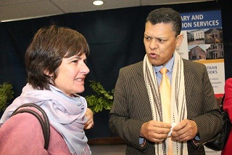  ATR-chairperson, Dr Michael le Cordeur and the guest speaker, Prof Maureen Robinson | 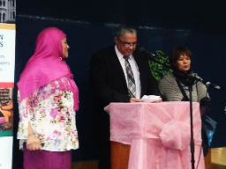  The project team who made the day possible was Francis Hearne, chief librarian from Atlantis, Mr Waldy Kastoor, Head of Parkview Primary, en Ria Olivier, ATR project manager
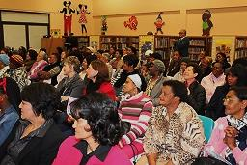  A Big crowd attended Women’s Day celebrations in Atlantis |  | 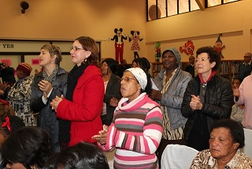  Dean receives standing applaus after her speech
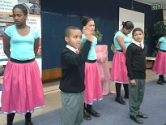  Parkview Primary learners during their performance of the Sharpeville drama | 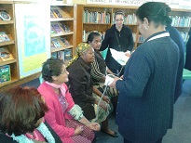  World Vision supplies free health services

